DATA 201 Fall 2024
Final Project Executive Summary
Olivia Yuengling

Introduction
The dataset I have selected is the CIA factbook dataset. The data is derived from the CIA 2014 world factbook. “The World Factbook provides basic intelligence on the history, people, government, economy, energy, geography, environment, communications, transportation, military, terrorism, and transnational issues for 265 world entities.” states Andres Renso Caceres Rossi (tidytuesday/data/2024/2024-10-22/readme.md at main_rfordatascience/tidytuesday. (2024). GitHub. <https://github.com/rfordatascience/tiddeathytuesday/blob/main/data/2024/2024-10-22/readme.md>). The dataset focuses on more population-based information sorted by each country. The dataset would be essential for analyzing basic characteristics of a country including the name, area, internet users, mortality rates, and population. The CIA factbook dataset can be utilized to investigate how the listed variables interact and correlate with one another. The target variable for the prediction algorithms will be the net migration rate, where we will use the other variables in the dataset and observe which ones are the best at predicting the net migration rate. We will use both linear and polynomial regression models to investigate if one or the other is more proficient at predicting a country’s migration rate. For the classification model, we will attempt to see if we can classify if countries are 3rd world or not. We will understand if the variables in the dataset are proficient at predicting the migration rate and if the classification model to predict if a country is a 3rd world country works proficiently by using logistic regression, random forest, and ANN (Artificial Neural Networks) models.
Analysis:
The regression models used have been created to estimate the net migration rate for a country. The variables in the dataset are presented in Table 1. Descriptive statistics are exhibited in Table 2. Figure 1 displays a correlation heatmap between the variables within the dataset. The analysis involved a multinomial linear regression and a polynomial regression model. The variables (Table 1) and their respective descriptive statistics (Table 2) are displayed in the tables below. Similarly, classification models were developed to predict whether country can be classified as third world or not. Logistic regression, random tree, and artificial neural network (ANN) models were used for classification with a focus on feature importance and model importance.
Table 1, Variables used:
Variable Name | Variable Description
country | Name of the country (factor with 259 levels)
area | Area of the country in square kilometers
birth_rate | Birth rate (number of live births per 1,00 people)
death_rate | Death rate (number of deaths per 1,000 people)
infant_mortality_rate | Infant mortality rate (number of deaths of infants under one year old per 1,000 live births)
internet_users | Number of internet users
life_exp_at_birth | Life expectancy at birth (in years)
maternal_mortality_rate | Maternal mortality rate (number of maternal deaths per 100,000 live births)
net_mirgration_rate | Net migration rate (number of migrants per 1,000 people)
population | Total population of the country
population_growth_rate | Population growth rate (multiplier)
third_world | Classifies third world and non-third world countries
Table 2, Descriptive Statistics
Variable name | Min | 1st Quartile | Mean | Median | 3rd Quartile | Max
area | 2.00 | 5836 | 87971 | 608449 | 448124 | 17098242
birth_rate | 6.72 | 11.84 | 16.89 | 19.66 | 24.91 | 46.12
death_rate | 1.53 | 5.93 | 7.54 | 7.91 | 9.46 | 17.49
infant_mortality_rate | 1.81 | 6.21 | 14 | 24.53 | 38.66 | 117.23
internet_users | 900 | 113150 | 746000 | 7953536 | 4012750 | 389000000
life_exp_at_birth | 49.44 | 67 | 74.29 | 71.78 | 78.25 | 89.57
maternal_mortality_rate | 2 | 26.75 | 65.5 | 157.89 | 200 | 2054
net_migration_rate | -113.51 | -2.01 | -0.06 | -0.12 | 1.25 | 83.82
population | 5215 | 0.33 | 1.08 | 1.14 | 1.92 | 9.37
population_growth_rate | -9.73 | 0.33 | 1.08 | 1.14 | 1.92 | 9.37

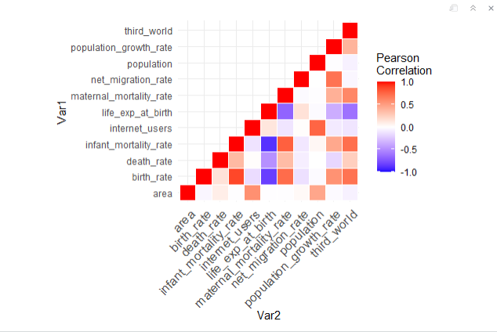
Figure 1: Correlation Matrix
As seen, the variables that may have a correlation with net_migration_rate are birth_rate, death_rate, and infant_mortality_rate. The variable infant_mortality_rate wound up not being statistically significant according to summary statistics of the full baseline linear regression model.

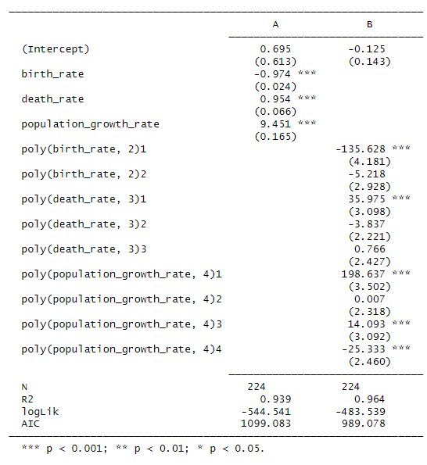
Results: Regression
The analysis compares two models to understand the relationships between key demographic indicators and their impact. Model A (linear regression model) includes simple linear terms for birth_rate, death_rate, and population_growth_rate, all of which are statistically significant predictors. However, Model B (polynomial regression model) incorporates polynomial terms for these variables, capturing nonlinear relationships and improving the overall model fit. Model B explains more variance, with an adjusted R² of 0.964 compared to 0.939 for Model A, and a lower AIC value (989.078 vs. 1099.083), indicating superior performance. Significant polynomial terms, particularly for birth_rate and population_growth_rate, suggest these variables have more complex effects than a simple linear trend can capture. Given its stronger fit and better performance metrics, Model B is preferred for understanding the intricate relationships between the predictors and the response variable.

Results: Classification
 | Logistic Regression | Random Forest | ANN
Accuracy | 0.9302 | 0.8729618 | 0.8901789
Kappa | 0.7802 | 0.5516664 | 0.6312402
Precision | 0.7777778 | 0.3333333 | 0.7777778
Recall | 0.875 | 0.5 | 0.7777778
F1 Score | 0.8235294 | 0.8235294 | 0.7777778

The classification results for predicting the dependent variable (third_world) were assessed by using three classification models: Logistic Regression, Random Forest, and Artificial Neural Network (ANN). These models were evaluated based on accuracy, kappa, precision, recall, and F1 score. Logistic Regression exhibited the highest accuracy (93.02%) and kappa (0.7802), indicating its strong overall performance and reliability in aligning with true classifications. It also achieved balanced precision (0.7778) and recall (0.875), resulting in the highest F1 score (0.8235), making it both interpretable and effective.
Random Forest had an accuracy of 87.30% and moderate kappa (0.5517), but its low precision (0.3333) and recall (0.5) limited its utility. Although it achieved the same F1 score (0.8235) as Logistic Regression, its lack of interpretability and imbalanced metrics make it less favorable. ANN showed competitive accuracy (89.02%) and strong recall (0.7778), but its F1 score (0.7778) was lower than that of Logistic Regression, and it shares the drawback of being less interpretable.
Logistic Regression is the preferred model due to its superior accuracy, well-balanced metrics, and interpretability. While ANN and Random Forest demonstrate potential, their lower precision and interpretability issues make them less desirable for this application.
Conclusion
In conclusion, the analysis demonstrates that a polynomial regression model is more effective in capturing the nonlinear relationships between demographic indicators and net migration rate, with higher explanatory power and better performance metrics than a linear regression model. For classification, Logistic Regression outperformed Random Forest and ANN models in terms of accuracy, kappa, and F1 score, making it the preferred choice for predicting whether a country is classified as third world. However, the low precision and recall of the Random Forest model indicate areas where feature selection and model tuning could improve future analyses. Further research could focus on incorporating additional variables or external datasets to enhance predictive accuracy and exploring more advanced machine learning algorithms for improved classification.

